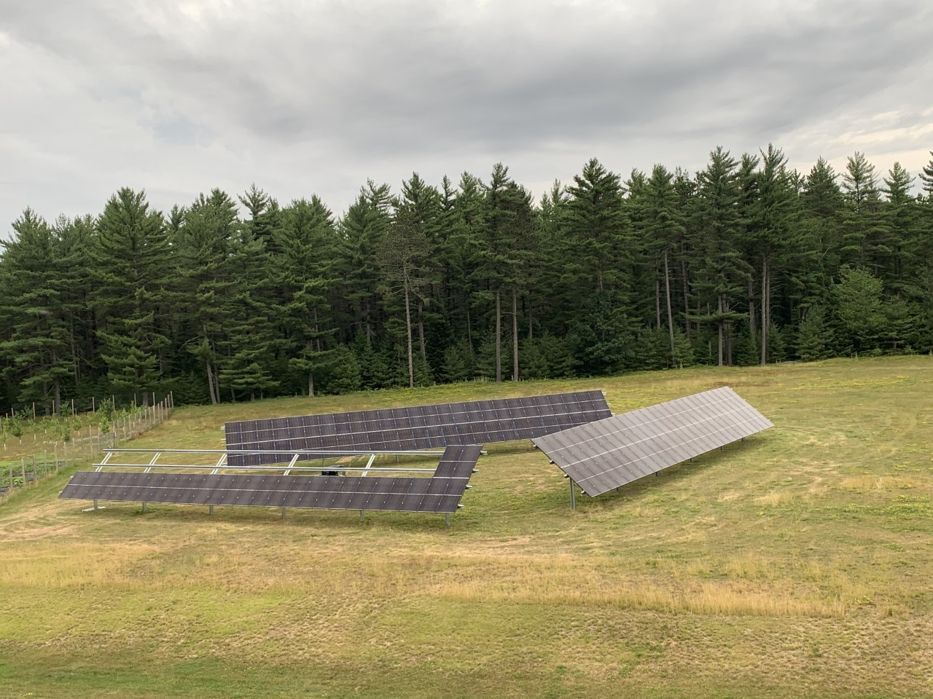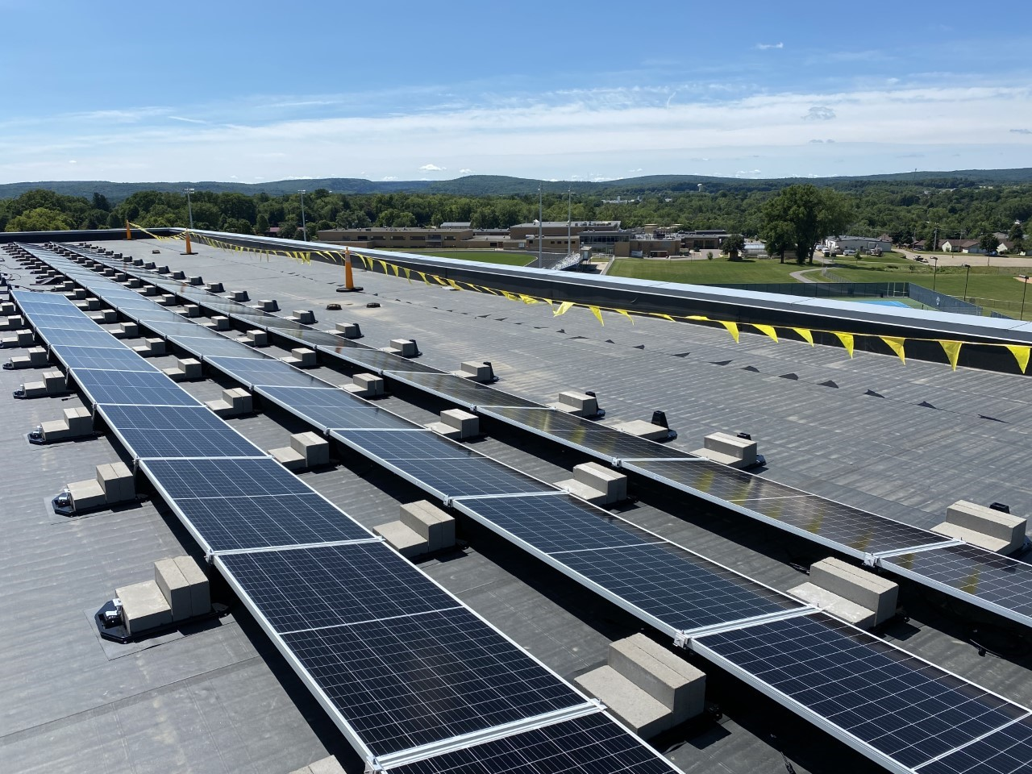
For Immediate Release: August 9, 2022

Contact:
Scott Pigeon
Hoffman Planning, Design & Construction, Inc. | Director of Marketing
Phone: 920-380-2175 | Email: spigeon@hoffman.net

Let the Sun Shine In
Wisconsin school districts turn to solar power

(Appleton, Wis.) – Public schools in Wisconsin spend more than $175 million each year on energy, typically the largest expense for a school district outside of personnel. So, it’s no surprise that more and more school districts are turning to the lowest cost electricity generation option – on-site solar PV (photovoltaic) systems – as well as Battery Energy Storage Systems (BESS).

Hoffman Planning, Design & Construction, Inc. has seen an increase in partnerships with school districts that focus on implementing solar power systems, which are proving successful in reducing energy costs.

“With solar PV system prices low even in the face of the recent trade dispute, relatively high electric rates with further increases on the horizon, and incentives available, the time is right for school districts to explore the use of solar energy,” stated Mark Hanson, director of sustainable services at Hoffman. “Additionally, on-site solar energy provides numerous educational opportunities for districts that are willing to incorporate solar energy education into their curriculum.”

Hoffman is currently assisting the Baraboo, Manawa, and Northland Pines school districts with their solar planning needs, with both Baraboo and Northland Pines currently in the middle of system installs that will be complete by the end of summer.

Previously, at the Darlington Community School District, Hoffman planned what was the largest solar PV system for a Wisconsin school district at the time. With solar panels on the roof of the elementary-middle school serving both that school and the adjacent high school, the District experienced energy savings, reduced its carbon footprint, and used the project as an educational opportunity for students and the community.

“There are some great success stories with the school districts we’ve been working with,” said Jody Andres, K-12 Market Leader at Hoffman. “Darlington is already planning to add a BESS and possibly expand their solar program. And with low solar PV system costs and grant dollars available, now is an ideal time for districts to take advantage of solar power.”

Solar PV systems have truly emerged as a strong option for school districts after decades of development, added Hanson. That progress has been aided by a number of grant programs, including the Wisconsin Solar on Schools program, Wisconsin Focus on Energy, and the Energy Innovation Grant program from the Public Service Commission of Wisconsin.

In fact, after Hoffman solar projects at three schools in the Northland Pines School District which used a mix of third-party investors and a special program offered by a local utility to fund the programs, the solar and BESS project at the District’s fourth school was funded by District-wide energy cost savings and by leveraging the three grant programs mentioned above.

“The grant dollars are definitely available,” said Hanson. “It’s just a matter of knowing who is offering them, determining an optimally sized system, and working through the grant application process.”

Andres commented that solar projects today are starting to include a Battery Energy Storage System since the generation provided by solar arrays is intermittent. With a BESS involved, power can be generated and stored to be used later to clip peak power demands and for when sunlight isn’t available.

Media note: photos of the Baraboo and Northland Pines solar projects are attached to this email.

###

Hoffman Planning, Design & Construction, Inc. is an integrated Total Project Management firm based in Appleton, Wisconsin. Hoffman’s mission is to make a positive impact on people’s lives and their environment by providing creative ideas and responsible solutions. Total Project Management (TPM), is Hoffman’s exclusive process that integrates efficient, healthy, and cost-effective building solutions that respect the environment while enhancing a building’s quality and value and reducing initial and long-term facility costs. Learn more at www.hoffman.net.

