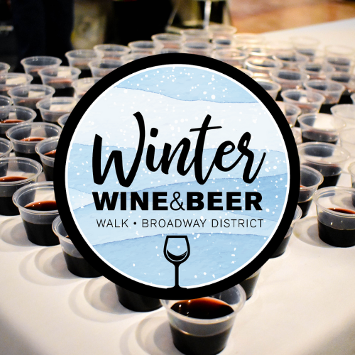
Fridays, December 2, 9 and 16
5:00 - 9:00 p.m.
Broadway District
The Winter Wine & Beer Walks, presented by Vos Electric, are taking place again this year on the first three Fridays in December. Enjoy tastings from local wineries, and breweries while visiting businesses and exploring the Broadway District.
This is a fantastic opportunity to shop for unique gifts at the many boutique shops, restaurants and other district venues located in the warmth of our inner city.
Tickets are on sale now for $35. The number of tickets sold is capped per night and typically do sell out.
Buy Tickets Here
