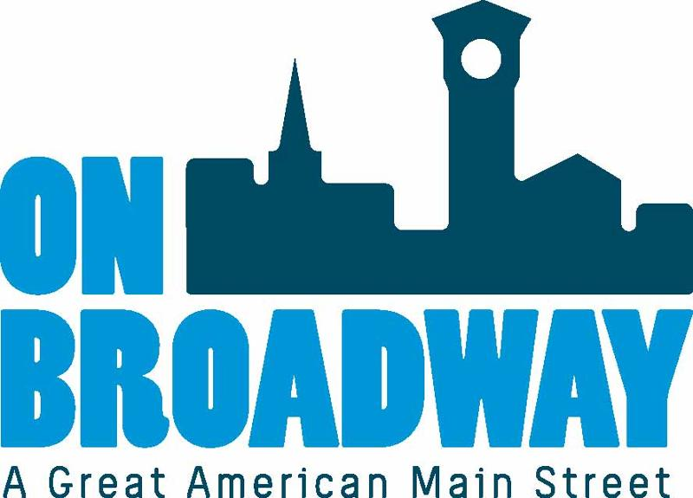
FOR IMMEDIATE RELEASE 04/20/22
Brooke Hafs
Marketing Director
On Broadway, Inc.
920-680-1226
brooke@onbroadway.org
Allie Thut
Director of Special Events
On Broadway, Inc.
920-569-3425
allie@onbroadway.org

Run for the Roses Wine Walk 2022
GREEN BAY, Wis. – On Broadway, Inc. is hosting the Run for the Roses Wine Walk, presented by Unison Credit Union, on May 7 from 1-5 p.m. The event features wine sampling at more than 15 participating businesses in the Broadway District in downtown Green Bay.
The event falls on the same day as the Kentucky Derby so it is being themed accordingly. Attendees are encouraged to dress in a fancy outfit or costume and accessorize with big hats, pearls and clutches.
Shop for unique products at the many boutique shops, restaurants and other districts along the route. At the end of the wine tour, swing by Old Fort Square to build a beautiful bouquet of flowers, included with event ticket, to take home and enjoy. The flowers will be provided by Petal Pusher.
A VIP Kentucky Derby viewing party is also being held from 4-7 p.m. on the second floor of The Depot. This part of the event will include Kentucky Derby inspired cocktails, hors d'oeuvre, live music, and a best dressed contest. Awards will be handed out to best hat, best individual and best group costumes. The big race starts at 4:45 p.m.
Registration is required for this event. General admission tickets are $30 in advance or $35 on the day of the event. VIP Party tickets are $20 in advance or $25 on the day of the event.
PURCHASE TICKETS

About On Broadway, Inc.
The historic Broadway District is the vibrant, engaging business and residential urban center of Northeast Wisconsin focusing on strategic marketing and staffing, funding and sustainability efforts, event development and coordination of promotions, business and residential recruitment and retention.
On Broadway, Inc. is a non-profit, community-based organization dedicated to strengthening the Green Bay community through economic development, historic preservation and promotion of downtown Green Bay’s Broadway District and the overall downtown community.

