FOR IMMEDIATE RELEASE 08/3/2022
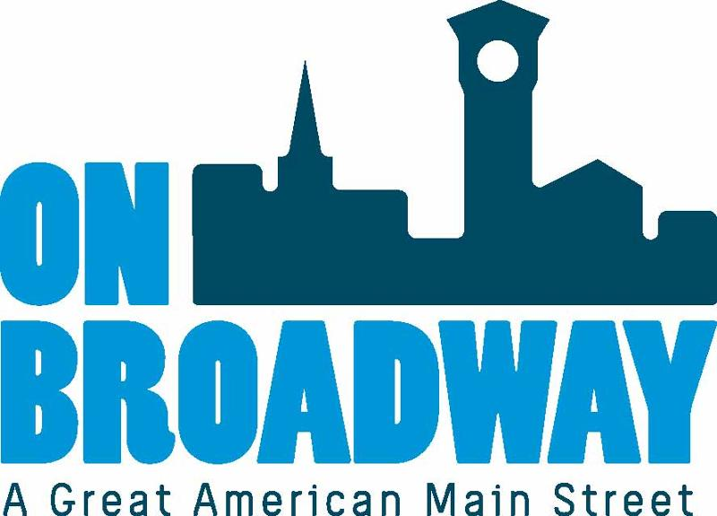
Chelsea Kocken
Director of Special Projects
On Broadway, Inc.
(920) 680-1684
chelsea@onbroadway.org
Brooke Hafs
Marketing Director
On Broadway, Inc.
(920) 680-1226
brooke@onbroadway.org

On Broadway, Inc. seeking public input on Green Bay Public Market
GREEN BAY, WI – On Broadway, Inc. staff is looking for the public to weigh in on the proposed Green Bay Public Market.
The preliminary plan for this project includes 42,965 square feet with room for approximately 20 businesses, a community event space, demo kitchen, dining area, and additional tenant space. OBI feels it is important to gather feedback from the public on a project like this to ensure the interests and needs of anticipated users are being met.
"This project will provide a quality-of-life amenity for the community and that means we want to engage the public in the discussion of what is most desired for a public market in our area," said Chelsea Kocken, Director of Special Projects for On Broadway, Inc. "The questions we ask within this survey are simple yet provide a good set of data for us to reference when securing tenants, scheduling programming, and working through the details of daily operations."
OBI has launched a survey for folks to offer up input. They are also hosting listening sessions in front of Old Fort Square (211 N Broadway) on Wednesday, August 24 and September 14 during the Farmers' Market on Broadway. Swing by anytime from 3 to 8 p.m. to discuss various topics regarding this exciting topic.
For more updates and information on the Green Bay Public Market, visit our website.
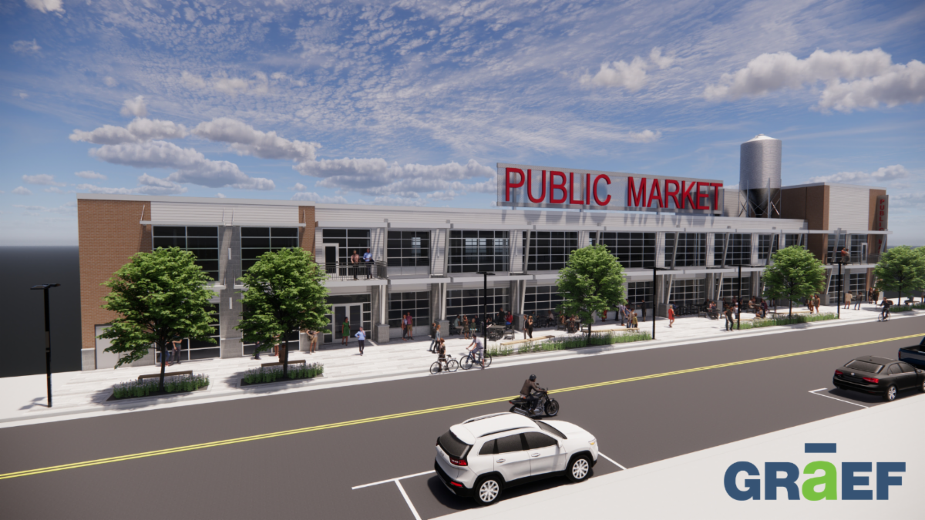
About On Broadway, Inc.
The historic Broadway District is the vibrant, engaging business and residential urban center of Northeast Wisconsin focusing on strategic marketing and staffing, funding and sustainability efforts, event development and coordination of promotions, business and residential recruitment and retention.
On Broadway, Inc. is a non-profit, community-based organization dedicated to strengthening the Green Bay community through economic development, historic preservation and promotion of downtown Green Bay’s Broadway District and the overall downtown community.

