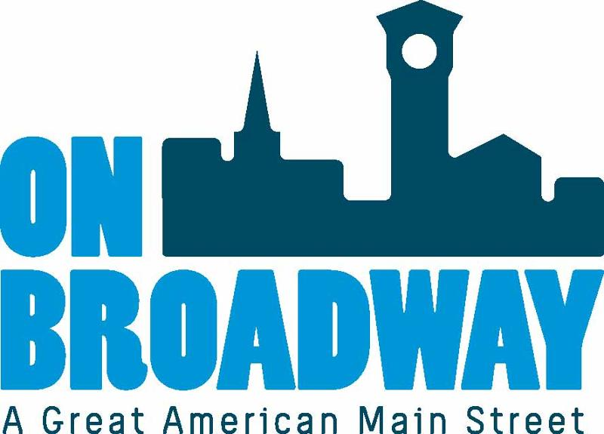
FOR IMMEDIATE RELEASE 11/29/2022
Brooke Hafs
Marketing Director
On Broadway, Inc.
920-680-1226
brooke@onbroadway.org
Chelsea Kocken
Director of Special Projects
On Broadway, Inc.
920-680-1684
chelsea@onbroadway.org

On Broadway, Inc. receives JEM Grant for Christkindlmarket
GREEN BAY, Wis. – On Broadway, Inc. was awarded a JEM (Joint Effort Marketing) Grant from the Wisconsin Department of Tourism to support the promotional efforts of the Broadway District's Christkindlmarket.
On Broadway, Inc. was awarded up to $20,000 in reimbursement funds that match 75% of dollars spent with media partners. On Broadway, Inc. has partnered with The Press Times, Fox11 and Discover Green Bay in additional to social media campaigns to promote the event.
A ceremonial check presentation will occur at the site of the Christkindlmarket at 164 N Broadway (Red Sculpture Park) on Wednesday, November 30 at 3:30 p.m.
Grant dollars will support the regional marketing efforts for this first year event that is being run as a pilot series. A Christkindlmarket is a German-traditional holiday market with vendors, festive programming, and German food and beverages. Christkindlmarkets are done throughout the world, but this event series is the first for the Greater Green Bay area.
The event has occurred three times this season and has seen great success with thousands attending. The idea of hosting this event in the heart of a downtown encourages foot traffic for local shops and restaurants as well as hotels with people traveling from beyond the immediate area to attend.
"We are very grateful to have been awarded this JEM Grant through the Wisconsin Department of Tourism," said Chelsea Kocken, Director of Special Projects. "It allows us to better promote this first time event to a larger audience, which is bringing more visitors to not only the event, but our district and the community. The event has already launched with such great success and we are excited to see if grow in future years."
The Christkindlmarket has three dates remaining in the series on Fridays, December 2, 9 and 16 from 5-9 p.m. and is held at 164 N Broadway.
For more information, visit our website.
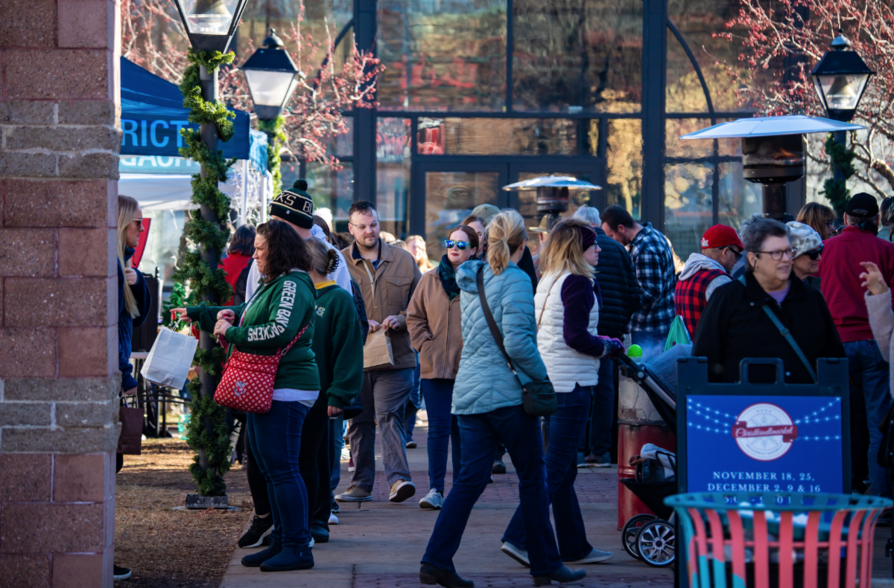
About On Broadway, Inc.
The historic Broadway District is the vibrant, engaging business and residential urban center of Northeast Wisconsin focusing on strategic marketing and staffing, funding and sustainability efforts, event development and coordination of promotions, business and residential recruitment and retention.
On Broadway, Inc. is a non-profit, community-based organization dedicated to strengthening the Green Bay community through economic development, historic preservation and promotion of downtown Green Bay’s Broadway District and the overall downtown community.

