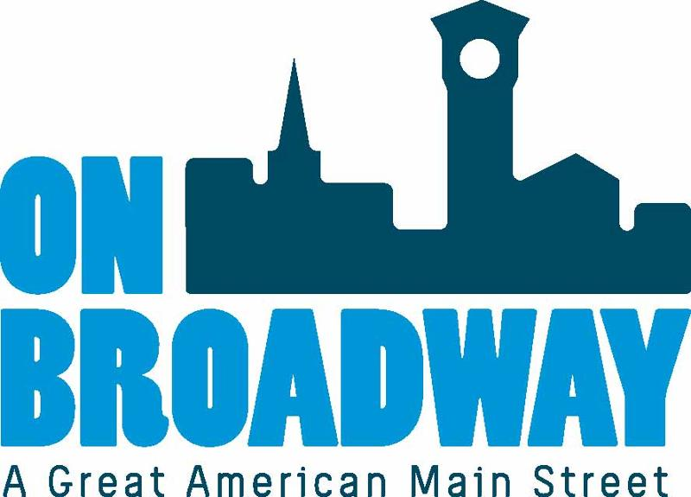
FOR IMMEDIATE RELEASE 04/25/22
Brooke Hafs
Marketing Director
On Broadway, Inc.
920-680-1226
brooke@onbroadway.org

On Broadway, Inc. and Gather earn statewide recognition at 31st Wisconsin Main Street Awards ceremony
GREEN BAY, Wis. – On Broadway, Inc. was recognized for its outstanding downtown revitalization efforts at the 31st Wisconsin Main Street Awards ceremony held in downtown Fond du Lac on April 22, 2022.
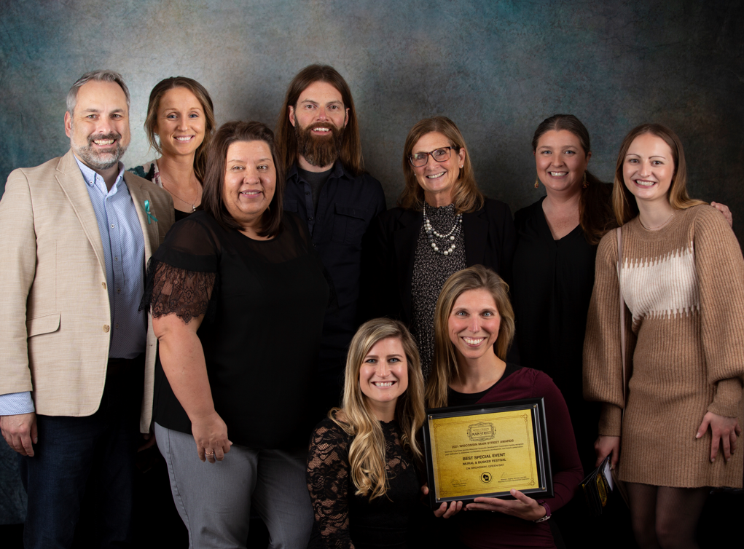
The Mural & Busker Festival, presented by Fox Communities Credit Union, took top honors in the Best Special Event category at the event, which was hosted by the Wisconsin Economic Development Corporation (WEDC). The awards ceremony recognized the efforts by Wisconsin Main Street volunteers and staff for their historic preservation and downtown economic development efforts of communities in Wisconsin in 2021.
"WEDC congratulates On Broadway, Inc. for its outstanding efforts to revitalize and improve downtown," said Missy Hughes, secretary and CEO of WEDC. "A vibrant downtown is critical to a community's overall economic development as well as the quality of life for its residents, and we commend On Broadway for being among the best in the state when it comes to strengthening its downtown."
"This is the third time in six years that On Broadway has been recognized for Best Special Event in the State of Wisconsin by Wisconsin Main Street. This is a highly competitive award category and it demonstrates our ability to coordinate and execute impactful events for the Broadway District and our community," said Brian Johnson, executive director with On Broadway, Inc.
On Broadway won Best Special Event in 2017 for igNight Market, and again in 2018 for Farmers' Market on Broadway.
In 2021, ten new murals were installed throughout the Broadway District during the Mural & Busker Festival. The event featured street performers, also known as buskers, live entertainment, food trucks, and muralists creating live artwork.
"The Mural & Busker Festival offers so much joy and excitement for those who attend," said Allie Thut, director of special events for On Broadway, Inc. "It is a one-stop shop for everything artistic. You can come out with the entire family and see all kinds of talented people showing off their craft."
This year's event will take place June 18-19 from noon to 4 p.m. For more information, visit our website.
The owners of Gather, Tommy and Jyll Everman, were recognized for adapting their operations successfully during the pandemic. They adjusted to maintain their brand as an experience venue and started creating cooking classes to go. Chef Jyll created YouTube videos to go along with each meal kit for people to enjoy at home.
"We are so grateful for this award and so thankful to our community for supporting our 'pivot' during such a crazy time," said Jyll Everman, co-owner of Gather. "The local support has made such an impact and we are thrilled to be open and back to doing what we love to do."
Tommy also helped lead an advocacy group to get grant money for live event venues that weren't qualifying in Wisconsin.
Gather started in the Broadway District in July 2016. They are considered a premier event space and host weddings, concerts, drag shows, and other private events.
Ken and Francine Rovinski were also recognized as Volunteers of the Year.
The couple received the honor for helping at the Farmers' Market on Broadway, igNight Markets, and Lighting Ceremony on Broadway. The Rovinskis put in more than 100 hours of volunteer service for On Broadway during event season. The duo always offers to lend a hand for hard-to-fill jobs and smile through each task with a great attitude.
About On Broadway, Inc.
The historic Broadway District is the vibrant, engaging business and residential urban center of Northeast Wisconsin focusing on strategic marketing and staffing, funding and sustainability efforts, event development and coordination of promotions, business and residential recruitment and retention.
On Broadway, Inc. is a non-profit, community-based organization dedicated to strengthening the Green Bay community through economic development, historic preservation and promotion of downtown Green Bay’s Broadway District and the overall downtown community.

