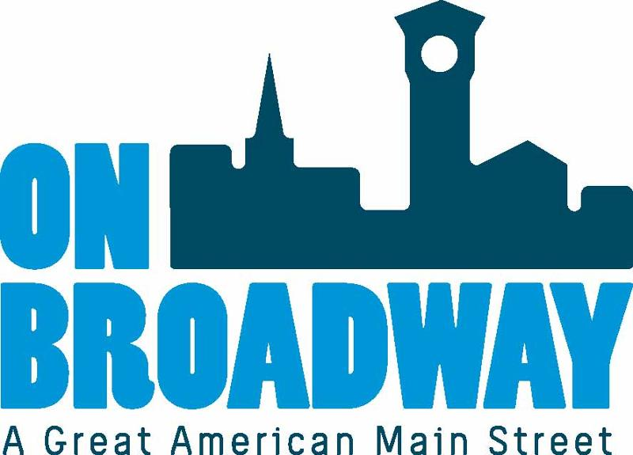
FOR IMMEDIATE RELEASE 11/15/2022
Brooke Hafs
Marketing Director
On Broadway, Inc.
920-680-1226
brooke@onbroadway.org
Chelsea Kocken
Director of Special Projects
On Broadway, Inc.
920-680-1684
chelsea@onbroadway.org

On Broadway Receives $90K, Multi-Year Grant to
Present the Levitt AMP Green Bay Music Series through 2025
GREEN BAY, Wis. – The Mortimer & Mimi Levitt Foundation has announced On Broadway, Inc. in Green Bay, Wisconsin has been awarded a multi-year Levitt AMP Green Bay Grant Award of $90K in matching funds to present a FREE outdoor music series at Leicht Memorial Park in 2023, 2024, and 2025.
Reflecting the Levitt Foundation’s commitment that all Levitt projects be community-driven, the 2023–2025 grant recipients were selected following a public voting period and comprehensive internal review process. Combining 15 new and 18 returning grantees, the Levitt Foundation will award $3 million dollars to nonprofits serving small to mid-sized towns and cities across the U.S. as part of the Levitt AMP Music Series, featuring a diverse lineup of artists, music genres and cultural programming to create inclusive experiences that are welcoming to all members of the community.
"We are excited to activate Leicht Park in the coming years with vibrant, diverse, original artists who our community members can truly connect with," said Chelsea Kocken, Director of Special Projects with On Broadway, Inc. "These free concerts are exactly the type of activity our residents have been asking for. It is a true testament to the people who live here that we were awarded this grant. You voted and now we will deliver more unique entertainment to the Broadway District and support a wide variety of artists along the way."
“Since the Levitt AMP Grant Awards began in 2015, we’ve seen grassroots nonprofits inspire transformation in their towns and cities through free outdoor concerts—activating underused public spaces, ensuring access to the arts, sparking additional investments, and strengthening the social fabric of their communities. Positive change happens when people of all ages and backgrounds come together and we’re thrilled to support changemakers like On Broadway,” says Sharon Yazowski, Executive Director of the Levitt Foundation. “We’re excited for the return of the Levitt AMP Green Bay Music Series to elevate Leicht Memorial Park as a gathering destination for all, delivering stellar performances and culturally diverse experiences for the entire community.”
The Levitt AMP Grant Awards is an exciting, multi-year matching grant opportunity bringing the joy of free, live music to towns and cities with a population of up to 250,000 people. For the 2023–2025 grant cycle, the Levitt Foundation expanded the Levitt AMP program from an annual matching grant of $25K into a three-year matching grant of $30K per year, for a total grant award of $90K per recipient. In April, the Levitt Foundation invited nonprofits to submit proposals that would reflect the three goals of the Levitt AMP awards: Amplify community pride and the city’s unique character; enrich lives through the power of free, live Music; and illustrate the importance of vibrant public Places.
On Broadway was previously awarded this grant for a concert series in 2019.
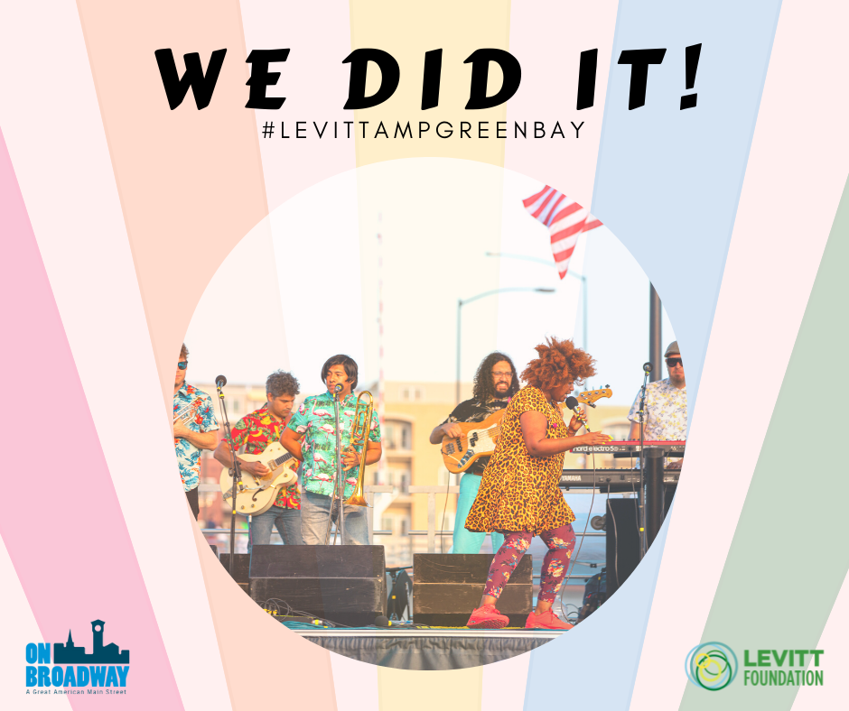
About On Broadway, Inc.
The historic Broadway District is the vibrant, engaging business and residential urban center of Northeast Wisconsin focusing on strategic marketing and staffing, funding and sustainability efforts, event development and coordination of promotions, business and residential recruitment and retention.
On Broadway, Inc. is a non-profit, community-based organization dedicated to strengthening the Green Bay community through economic development, historic preservation and promotion of downtown Green Bay’s Broadway District and the overall downtown community.
About the Mortimer & Mimi Levitt Foundation
The Mortimer & Mimi Levitt Foundation is a private family foundation that exists to strengthen the social fabric of America. Through its commitment to creative placemaking, the Levitt Foundation supports the activation of underused public spaces—such as neglected parks, vacant downtown lots, and former brownfields—into welcoming, inclusive destinations where the power of free, live music brings people together to create more equitable, healthy and thriving communities. The Foundation’s primary funding areas include Levitt venues and the Levitt AMP [Your City] Grant Awards. Both of these programs present free concerts in outdoor, open lawn settings featuring high-caliber talent in a broad array of music genres and cultural programming. Levitt venues and Levitt AMP concert sites attract people of all ages and backgrounds and reflect the character of their town or city, while benefitting from the framework and best practices of the Levitt program.
The Levitt Foundation invests in community-driven efforts that harness the power of partnerships and leverage community engagement. Levitt venue nonprofits and AMP grantees partner with other local nonprofits and community groups to inform programming, outreach and engagement, embodying the Foundation’s funding philosophy and core values to support projects that are

