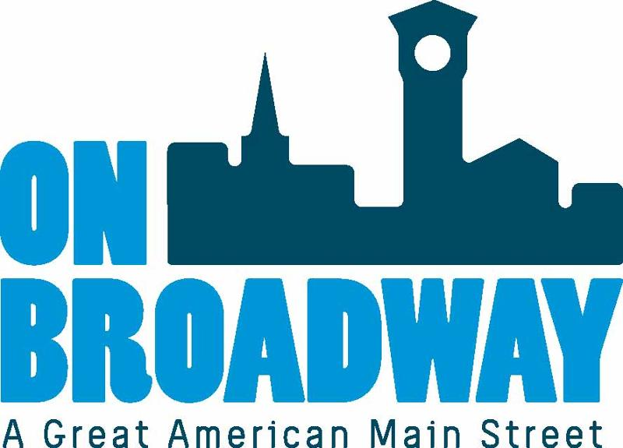
FOR IMMEDIATE RELEASE 05/04/2022
Allie Thut
Director of Special Events
On Broadway, Inc.
(920) 639-6284
allie@onbroadway.org

Brooke Hafs
Marketing Director
On Broadway, Inc.
(920) 680-1226
brooke@onbroadway.org

Mural & Busker Festival 2022
GREEN BAY, Wis. -- On Broadway, Inc. is happy to announce the return of the Mural & Busker Festival, presented by Fox Communities Credit Union, coming up June 18-19 in the Broadway District.
The event will feature street performers, also known as buskers, and muralists creating live artwork on building exterior walls throughout the Broadway District.
On Saturday and Sunday, folks are invited to stop out and watch ten murals come to life. The festival also features buskers, or street performers, from noon to 4 p.m. The buskers include musicians, jugglers, dancers, magicians and other live art performers engaging with guests.
As you walk the streets of the Broadway District, there will be art surrounding you. This event is a one stop shop for all things creative. Art vendors will also be out and about with tables selling their hand made products. There will also be food trucks and beverages on site.
There will be a community art project to participate in as well. All of the benches and garbage cans throughout the district are going to be re-painted in an artistic way during this event. Volunteers can sign up ahead of time to help.
"Fox Communities Credit Union is excited to team up with On Broadway again as the presenting sponsor of the Mural and Busker Festival," said Heather Wessley, the Community Engagement Manager with Fox Communities Credit Union. "This is such a wonderful event to support local arts while beautifying the Broadway District."
“The Mural and Busker Festival showcases incredible artists and performers in our community. We are also thrilled this year to bring in outside talent to diversify guest experience,” said Allie Thut, Director of Special Events for On Broadway, Inc. “This event brings so much joy and life to the Broadway District. It not only entertains the masses for an entire weekend, but it also creates a long-lasting impact in our slice of downtown Green Bay. These beautiful pieces of artwork are a draw for people to come to our district time and time again."
Locations for each mural being created is being finalized and will be released soon. We will also be featuring all of our artists on our website.
About On Broadway, Inc.
The historic Broadway District is the vibrant, engaging business and residential urban center of Northeast Wisconsin focusing on strategic marketing and staffing, funding and sustainability efforts, event development and coordination of promotions, business and residential recruitment and retention.
On Broadway, Inc. is a non-profit, community-based organization dedicated to strengthening the Green Bay community through economic development, historic preservation and promotion of downtown Green Bay’s Broadway District and the overall downtown community.

