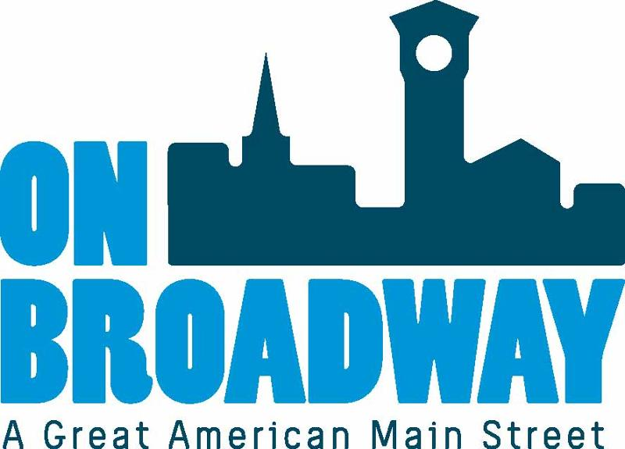
FOR IMMEDIATE RELEASE 11/17/2022
Brooke Hafs
Marketing Director
On Broadway, Inc.
920-680-1226
brooke@onbroadway.org
Allie Thut
Director of Special Events
On Broadway, Inc.
920-569-3425
allie@onbroadway.org

Lighting Ceremony on Broadway kicks off holiday season
GREEN BAY, Wis. – The annual Lighting Ceremony on Broadway, presented by Tundraland and Renewal by Andersen, will be held Friday, November 18 from 5 - 8 p.m. in the Broadway District.
This event officially kicks off the holiday season in the district and includes visits with Santa, cookie decorating, horse drawn sleigh rides, carolers and so much more. Broadway businesses will be open for visitors to browse and get a start on their holiday shopping. There will be an Elf on the Shelf scavenger hunt at participating businesses this year.
The official countdown to the illumination will be officiated by Green Bay Mayor Eric Genrich at 5:30 p.m. at the corner of Broadway and Hubbard Street. Two High School Choirs will be performing during the ceremony.
"The Broadway District is a magical place during the holiday season," said Betsy Sorensen, Special Events Manager for On Broadway, Inc. "This family-friendly event is the perfect way to get in the holiday spirit and explore all of the unique retailers, restaurants and other district businesses. We encourage the community to come check it out and get a start on holiday shopping while supporting our small business owners."
On Broadway, Inc. is launching a pilot series of a Christkindlmarket on the same night as the Lighting Ceremony on Broadway. The market will run 5 to 9 p.m. in Red Sculpture Park.
For more information, visit our website.
######
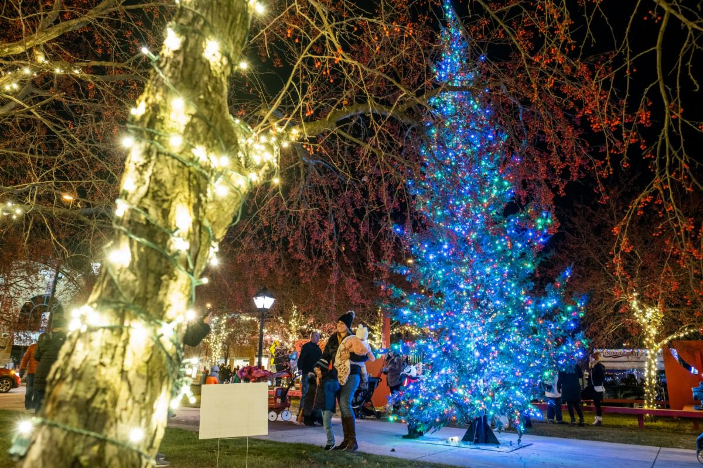
Thank you to our sponsors!
About On Broadway, Inc.
The historic Broadway District is the vibrant, engaging business and residential urban center of Northeast Wisconsin focusing on strategic marketing and staffing, funding and sustainability efforts, event development and coordination of promotions, business and residential recruitment and retention.
On Broadway, Inc. is a non-profit, community-based organization dedicated to strengthening the Green Bay community through economic development, historic preservation and promotion of downtown Green Bay’s Broadway District and the overall downtown community.

