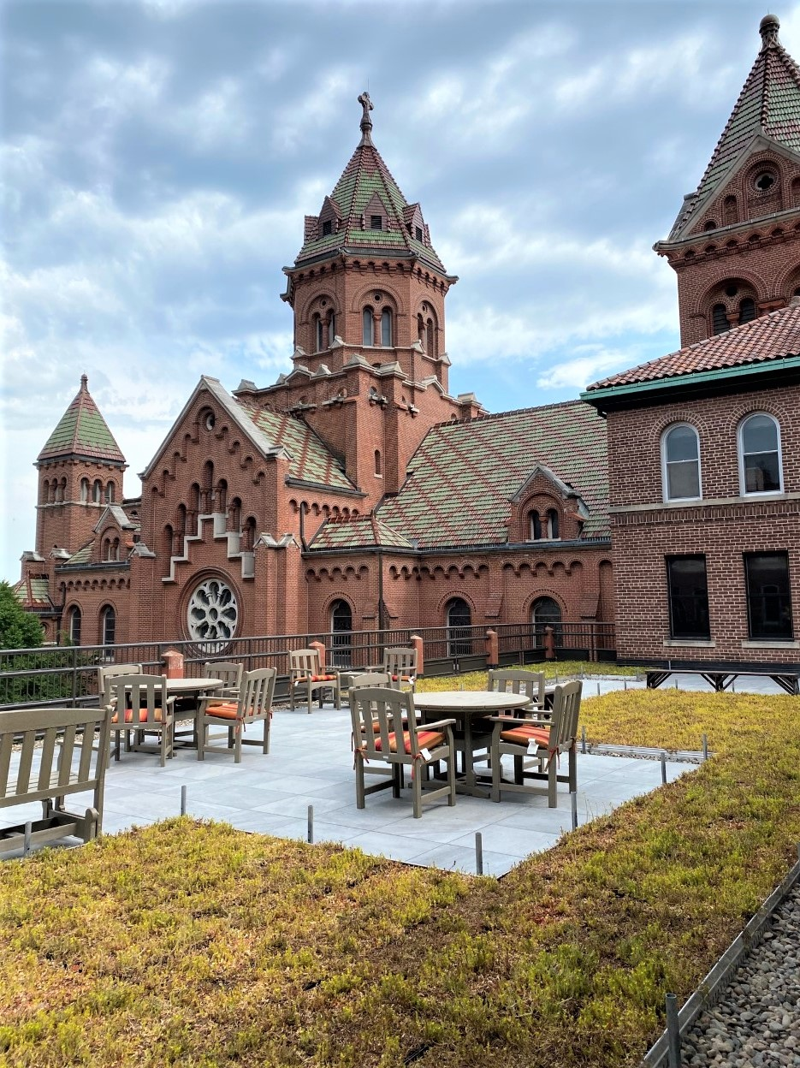
For Immediate Release: April 27, 2022

Contact:
Scott Pigeon
Hoffman Planning, Design & Construction, Inc. | Director of Marketing
Phone: 920-380-2175 | Email: spigeon@hoffman.net

Hoffman Completes Renovation at Franciscan Home in La Crosse

(Appleton, Wis.) – The Franciscan Sisters of Perpetual Adoration (FSPA) in La Crosse, Wis. celebrated with a recent blessing ceremony the completion of a six-year journey to renovate their home, St. Rose Motherhouse. The renovation project unites all FSPA sisters together under one roof and provides all levels of care for their retired and for sisters that will move from their care center in Villa St. Joseph.

FSPA selected Hoffman Planning, Design & Construction, Inc. to assist them in their planning efforts as well as provide comprehensive design and construction management services. The project involved remodeling significant portions of the building and additions to accommodate skilled and memory care residents, new community spaces, wellness and support areas, dining and food service updates, additional guest rooms, and a green roof accessible for all sisters with direct access from the memory care floor. Accessibility features, including two new elevators—one at their primary entrance with a new drop-off drive area and a second that provides direct access to the sisters’ private courtyard—were also part of the overall project.

Sr. Sue Erstner, FSPA Vice President, says the accessibility improvements are significant. “Prior to the renovation there was only one entrance to the building that didn’t include steps,” she said. “Now we have several entrances that are accessible, and this is critical as we bring all of our sisters together at St. Rose.”

“Working with the sisters to address their care needs, while renovating a wonderful structure, was very rewarding,” said Julie Heiberger, Hoffman’s Religious Market Leader. “With these upgrades and improvements, St. Rose Motherhouse will serve the sisters’ needs for decades to come, and we were honored to assist them.”

###

Hoffman Planning, Design & Construction, Inc. is an integrated Total Project Management firm based in Appleton, Wisconsin. Hoffman’s mission is to make a positive impact on people’s lives and their environment by providing creative ideas and responsible solutions. Total Project Management (TPM), is Hoffman’s exclusive process that integrates efficient, healthy, and cost-effective building solutions that respect the environment while enhancing a building’s quality and value and reducing initial and long-term facility costs. Learn more at www.hoffman.net.

