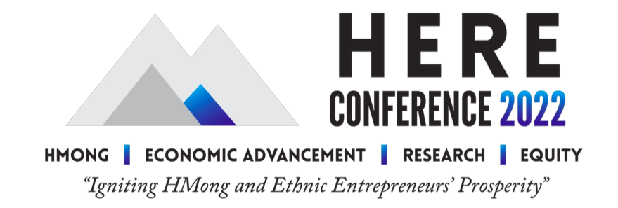
*MEDIA NOTE: Note: the spelling “HMong” is used rather than “Hmong” throughout conference literature as an inclusive acknowledgement of the two main dialects—Green, or Moob Leeg, and White, or Hmoob Dawb—spoken by HMong communities.
FOR IMMEDIATE RELEASE

From big ideas to personalized advice: HERE Conference speakers provide range of helpful perspectives
Experts to address improving HMong* and ethnic Americans’ wealth equity, entrepreneurship resources
EAU CLAIRE, WIS. [July 12, 2022]— What do a federal rural housing administrator, a second-generation family business owner, and an Iron Chef challenger all have in common? They are all featured speakers at the 2022 HMong Economic Advancement, Research, and Equity (HERE) Conference and Summit organized by the HMong American Leadership and Economic Development (HALED) organization of Eau Claire.
“I am thrilled to have speakers with such a diverse set of experiences and strengths for the inaugural HERE Conference,” said Mai Xiong, HERE Conference chair and founder, president and CEO of HALED. “We want to spark a broader conversation about what it will take for HMong and ethnic entrepreneurs to build generational wealth, and that requires understanding individual-level resources and national trends. Improving ethnic entrepreneurs’ access to resources is a local, state, and federal issue, and these experts speak to each part of that equation.”
Expert speakers and thought leaders are featured throughout the HERE Conference and will explore strategies to build wealth equity for HMong and other ethnic entrepreneurs. You can learn more about the speakers here, and further information about each will be featured on the HERE Conference’s Facebook page leading up to the Sept. 14-16, 2022 event in Eau Claire.

Sept. 14-15—HERE Conference Days Keynote Speakers
• Representative Francesca Hong (WI-76), mother, chef, entrepreneur, and first Asian American elected to the Wisconsin Assembly
• Issac Kou Lee, Wausau-based owner of a second-generation family business with a passion for assisting minority business owners
Sept. 14—HERE Banquet Chef and Keynote Speaker
• Chef Yia Vang, proprietor of Twin Cities restaurant Union Hmong Kitchen and recent challenger on Netflix’s ‘Iron Chef: Quest For An Iron Legend’

Sept. 16—HERE Summit Panalists
• Missy Hughes, CEO of the Wisconsin Economic Development Corporation (WEDC)
• Joaquin Altoro, Administrator of the U.S. Department of Agriculture's Rural Housing Service
• Blong Xiong, State Executive Director of the USDA Farm Service Agency in California
• May Yer Thao, President and CEO of the Hmong American Partnership, the largest HMong - founded and HMong-led nonprofit in the country
“Whether you choose to attend in person or register to participate virtually, this conference will help you pursue your personal and professional goals while growing your network,” Xiong said.
Registration for each part of the HERE Conference is available now, with in-person and virtual options available. Registrations for the conference, summit, and/or banquet include meals.
For questions or additional comments, please contact Mai Xiong, 2022 HERE Conference Chair and Founder, President & CEO of HALED, at here.inquire@gmail.com.

About the Title Sponsor and Organizer
The Wisconsin Economic Development Corporation is proud to serve as the Wealth Equity Champion and Title Sponsor of the 2022 HERE Conference. The WEDC is committed to creating and maintaining a business climate that allows you to maximize your potential. Working with more than 600 statewide partners, including regional economic development organizations, academic institutions and industry groups, we’re enhancing our communities, supporting business development, advancing industry innovation, tapping global markets and developing a talented workforce to help Wisconsin realize its full economic potential.

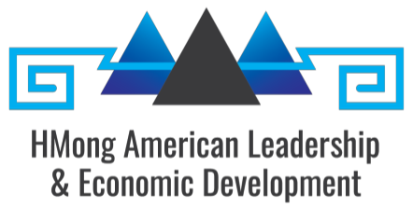
HMong American Leadership & Economic Development (HALED) of Eau Claire, WI is proud to partner with area leaders and organizations to present the 2022 HERE Conference and Summit Sept. 14-16, 2022. Our mission is to achieve economic wealth and social equity for HMong and Asian Americans through collective advocacy, leadership development, and access to resources. We envision a thriving community where everyone is socially and economically prosperous.

HALED is joined in planning the 2022 HERE Conference by many partners, including:
- City and county of Eau Claire
- CoLab
- Eau Claire Area Economic Development Corporation
- Hmong National Development
- Marshfield Clinic Health System
- Minnesota Hmong Chamber of Commerce
- New North
- Pablo Center at the Confluence
- Prevail Bank
- Royal Credit Union
- University of Wisconsin-Eau Claire
- UW Extension
- UW System Small Business Development Center
- Visit Eau Claire
- WEDC
- Wisconsin Department of Agriculture, Trade, and Consumer Protection
- Wisconsin Housing and Economic Development Authority

