FOR IMMEDIATE RELEASE 08/04/2022
Brooke Hafs
Marketing Director
On Broadway, Inc.
(920) 680-1226
brooke@onbroadway.org
Doma opens new office in the Broadway District
GREEN BAY, WI – Doma is hosting a ribbon cutting ceremony on Thursday, August 11 from 3:00 to 6:00 p.m. at their new office in the Broadway District. Their new branch is located at 111 N. Broadway in Suite 1A.
A ribbon cutting will take place at 4:30 p.m. and include remarks from City of Green Bay Mayor Eric Genrich; Brian Johnson, Executive Director for On Broadway, Inc.; and Chad Christy, Managing Director of Wisconsin at Doma.
Light refreshments and drinks will be served. All are welcome to attend and congratulate this team on their new start.
“Doma is extremely excited to be a part of the business community in Green Bay,” said Chad Christy, Doma Managing Director of Wisconsin. “In the real estate industry, it’s all about the people and the relationships—and our incredible Green Bay team is proud to bring Doma’s technology here to create a frictionless closing experience for everyone involved in a residential real estate transaction.”
About Doma
Doma is architecting the future of real estate transactions. As a leading independent title agency (formerly North American Title), they provide settlement services to homebuyers, sellers and borrowers.
For more information Doma, visit their website.
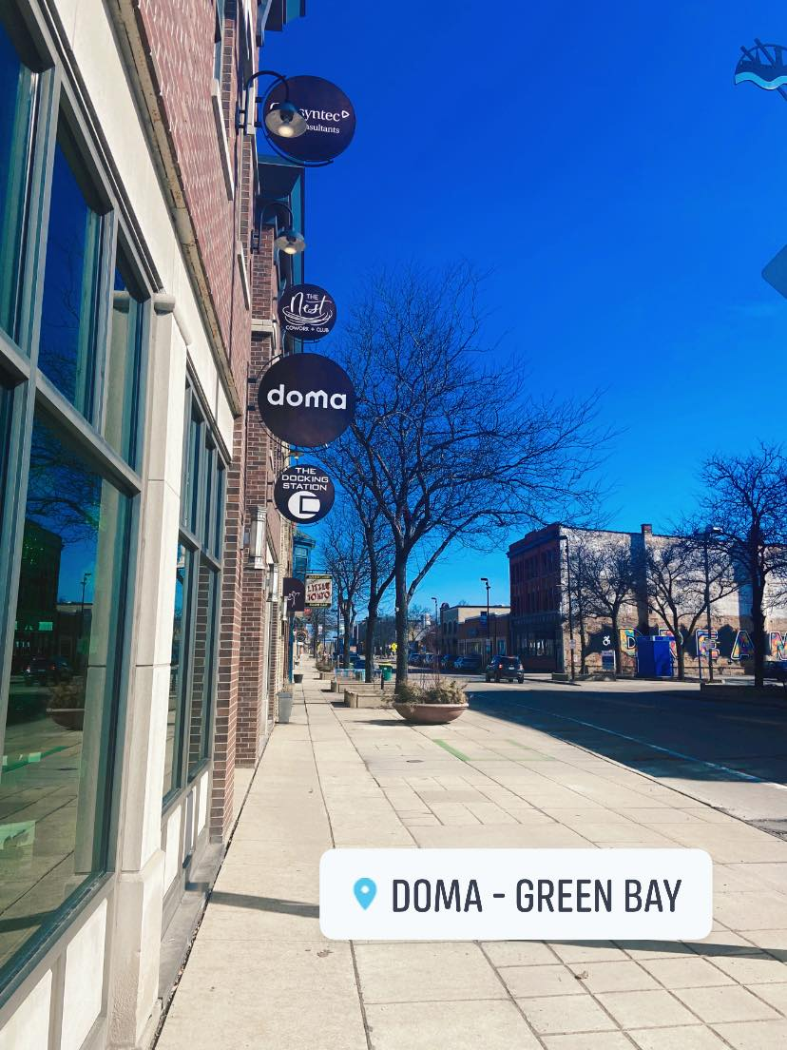
About On Broadway, Inc.

The historic Broadway District is the vibrant, engaging business and residential urban center of Northeast Wisconsin focusing on strategic marketing and staffing, funding and sustainability efforts, event development and coordination of promotions, business and residential recruitment and retention.
On Broadway, Inc. is a non-profit, community-based organization dedicated to strengthening the Green Bay community through economic development, historic preservation and promotion of downtown Green Bay’s Broadway District and the overall downtown community.

