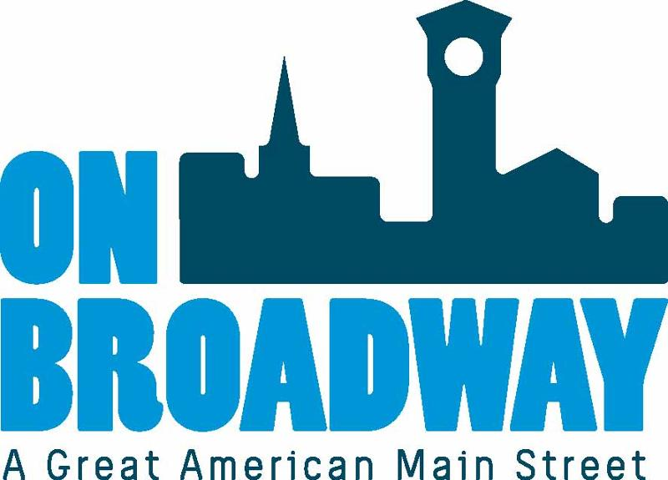
FOR IMMEDIATE RELEASE 08/10/2022
Brooke Hafs
Marketing Director
On Broadway, Inc.
(920) 680-1226
brooke@onbroadway.org

Cockloft Vintage opens business in the Broadway District
GREEN BAY, WI – Cockloft Vintage is hosting a ribbon cutting ceremony on Thursday, August 18 from 4:00 to 6:00 p.m. at their new store front in the Broadway District. The store is located at 163 N. Broadway.
A ribbon cutting will take place at 4:30 p.m. and include remarks from City of Green Bay Mayor Eric Genrich; Brian Johnson, Executive Director for On Broadway, Inc.; and Tina Kelly, Owner of Cockloft Vintage.
Light food and drinks will be served. All are welcome to attend and congratulate Tina on her new start.
"The best part has been watching guests find a particular item in the shop and seeing the excitement in their eyes or the joy in their voice, as they recall an intimate memory of a beloved family member," said Tina Kelly, Owner of Cockloft Vintage. "Many people reminisce and share a personal segment of their lives with me. It is a tribute and a representation of the shop that every piece truly has a story."
"We’re excited to add another retail destination to our shopping corridor. Cockloft Vintage carries a variety of products that cater to a broad audience of shoppers with eclectic interests," said Brian Johnson, Executive Director of On Broadway Inc. "We know the strong density of storefront options is what creates a shopping destination and it’s the perfect addition as we prepare for a busy holiday shopping season that supports our small business owners."
About Cockloft Vintage
Cockloft Vintage sells hand-selected, vintage goods and clothing. All items are preloved, sustainable and have a story.
For more information Cockloft Vintage, visit their website.
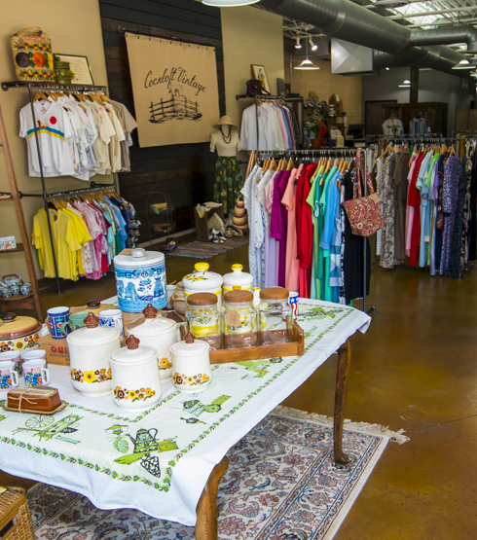
About On Broadway, Inc.
The historic Broadway District is the vibrant, engaging business and residential urban center of Northeast Wisconsin focusing on strategic marketing and staffing, funding and sustainability efforts, event development and coordination of promotions, business and residential recruitment and retention.
On Broadway, Inc. is a non-profit, community-based organization dedicated to strengthening the Green Bay community through economic development, historic preservation and promotion of downtown Green Bay’s Broadway District and the overall downtown community.

