News Release
Callie Davis promoted to DE&I director with Associated Bank
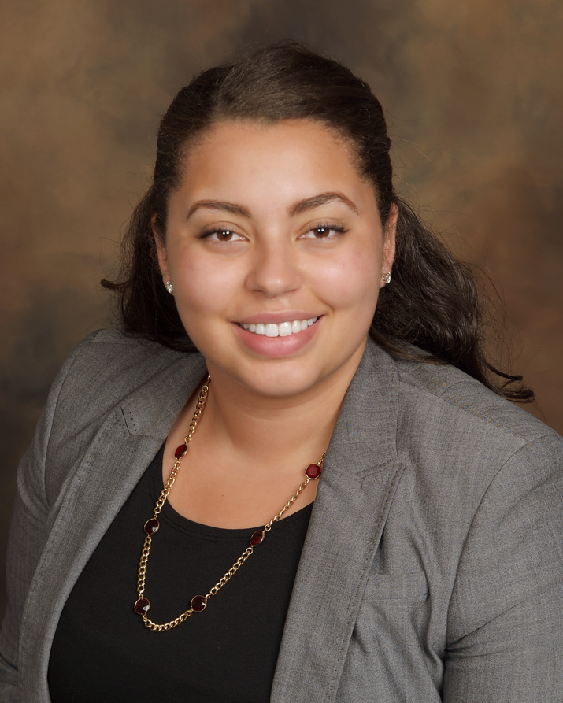

MILWAUKEE – April 28, 2022 – Associated Bank announces the promotion of Callie Davis to the role of senior vice president, director of diversity, equity & inclusion (DE&I), human resources. She is responsible for developing and executing on strategic initiatives, programs and processes in support of the bank’s commitment to DE&I.

Davis has been a member of the Associated Bank team since 2016 when she started as a participant in the corporate trainee program and has since held various roles in both talent acquisition and DE&I. During her tenure, her accomplishments have included strategic management of seven colleague resource groups (CRG) along with the creation of the bank’s Black CRG, creating and leading a talent acquisition CRG ally program, creation of courageous conversations colleague dialog sessions, the implementation of DE&I line of business champions and developing awareness and tools for hiring, developing and retaining underrepresented talent including, women, people of color, LGBTQ+, veterans, and individuals with disabilities at all levels of the organization.

Davis holds a Bachelor of Business Administration degree in finance, with a minor in social justice from UW – Oshkosh. In the community, she is an active member of the program committee for the Wisconsin chapter of Disability:IN.

She is located at the Associated Bank River Center, 111 E. Kilbourn Ave.

# # #

ABOUT ASSOCIATED BANC-CORP

Associated Banc-Corp (NYSE: ASB) has total assets of $35 billion and is Wisconsin's largest bank holding company. Headquartered in Green Bay, Wisconsin, Associated is a leading Midwest banking franchise, offering a full range of financial products and services from more than 200 banking locations serving more than 100 communities throughout Wisconsin, Illinois and Minnesota, and loan production offices in Indiana, Michigan, Missouri, New York, Ohio and Texas. Associated Bank, N.A. is an Equal Housing Lender, Equal Opportunity Lender and Member FDIC. More information about Associated Banc-Corp is available at www.associatedbank.com.

Contact: Jennifer Kaminski
Vice President | Public Relations Senior Manager
920-491-7576 | Jennifer.Kaminski@associatedbank.com

