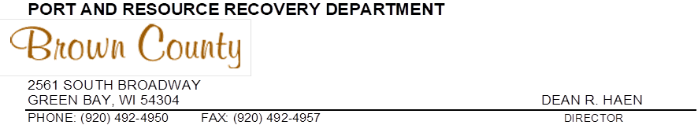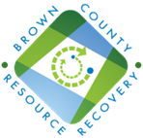
Brown County Hazardous Materials Recovery Facility to Close Saturdays

FOR IMMEDIATE RELEASE July 19, 2022
(Brown County, Wis.) – Due to ongoing staffing shortages, the Brown County Hazardous Material Recovery Facility (HMR) will no longer be open on Saturdays effective July 30. The HMR facility will remain open for residential drop-offs on Tuesdays (9:00 a.m.–3:00 p.m.) and Thursdays (noon–6:00 p.m.). The Tuesday hours will now be year-round.

“Unfortunately, given the current job market, we are no longer able to staff the Hazardous Material Recovery facility the way we had in the past,” said Mark Walter, business development manager for Brown County Resource Recovery. “We will remain open on Tuesdays and Thursdays for residential drop-off to make sure that we continue that availability for the residents and businesses we serve.”

The HMR facility collects hazardous materials to ensure those items are disposed of in a safe and environmentally responsible manner. Acceptable materials include paint, cleaners, chemicals, pesticides, fluorescent bulbs and electronics. Fees apply for many materials.

Those interested in dropping off hazardous materials are reminded that:
- Drivers must remain in vehicles
- All hazardous materials must be in the back end of the vehicle (trunk, lift gate or truck bed)
- Materials will not be removed from the front or back seats.

Anyone with a large amount of material needs to call Brown County Resource Recovery at (920) 492-4950 to make an appointment to drop off their material. All businesses, farms and non-profits are also required to make an appointment for drop off.

###

Brown County Resource Recovery: The purpose of the Brown County Port & Resource Recovery Department is to meet the solid waste disposal needs of local communities and businesses through methods which are environmentally sound and economical.

For more information, visit our website at: www.BrownCountyRecycling.org
Follow us on: Facebook | Twitter | YouTube | Pinterest

Media Contacts:
Mark Walter
Business Development Manager
Brown County Resource Recovery
(920) 492-4965

Scott Stein
Leonard & Finco Public Relations, Inc.
(920) 676-0711
sstein@lfpublicrelations.com

