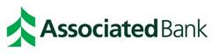
News Release
Associated Bank welcomes Joy Langreder as director of talent acquisition and development
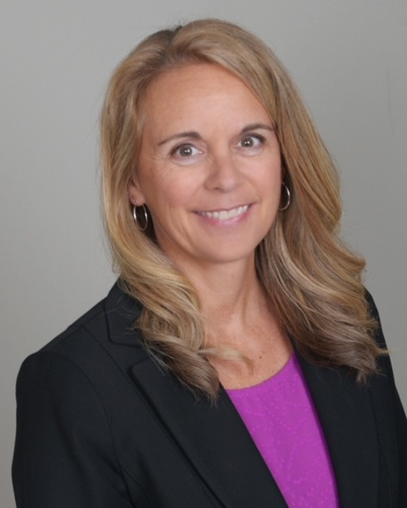
GREEN BAY, Wis. – April 28, 2022 – Joy Langreder has joined Associated Bank as senior vice president & director of talent acquisition and development, human resources. She is responsible for planning and implementing strategies, programs and tools needed for success in talent management.

Langreder brings more than 25 years of human resources and talent management experience to Associated Bank. Previously, she held the position of HR director – talent acquisition at Schneider National, Inc., where she was responsible for creating talent acquisition strategy, building the talent acquisition team and implementing new technology to support hiring for office, mechanic and warehouse positions. Prior, she held leadership roles at Schneider National, Inc. including HR director, preceded by HR business partner.

Langreder holds an MBA from UW – Oshkosh and a Bachelor of Business Administration degree with a double major in business and French from the University of Wisconsin – La Crosse. In the community, Langreder previously served on the Women’s Fund of Greater Green Bay Power of the Purse Planning Committee, in addition to volunteer roles with Habitat for Humanity, the Service League of Green Bay and the NEW Community Shelter. In addition, she co-founded Schneider Women’s Network, Schneider’s first employee resource group, providing rich career development opportunities and networking, for over a decade.

She is located at 433 Main St.

# # #

ABOUT ASSOCIATED BANC-CORP
Associated Banc-Corp (NYSE: ASB) has total assets of $35 billion and is Wisconsin's largest bank holding company. Headquartered in Green Bay, Wisconsin, Associated is a leading Midwest banking franchise, offering a full range of financial products and services from more than 200 banking locations serving more than 100 communities throughout Wisconsin, Illinois and Minnesota, and loan production offices in Indiana, Michigan, Missouri, New York, Ohio and Texas. Associated Bank, N.A. is an Equal Housing Lender, Equal Opportunity Lender and Member FDIC. More information about Associated Banc-Corp is available at www.associatedbank.com.

Contact: Jennifer Kaminski
Vice President | Public Relations Senior Manager
920-491-7576 | Jennifer.Kaminski@associatedbank.com

