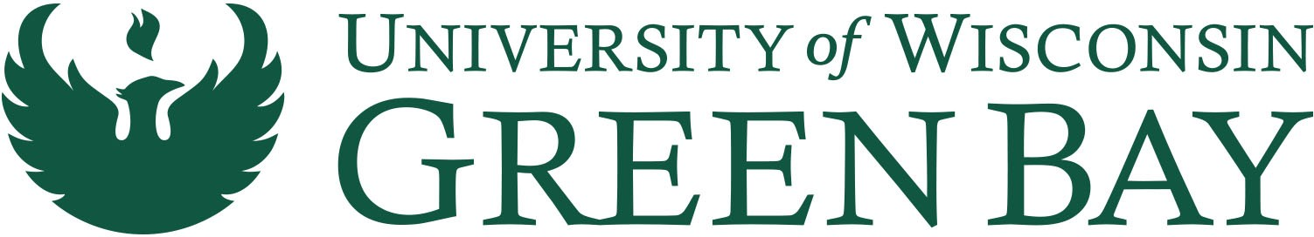
CONTACT: Kristin Bouchard
News
PHONE: 920-465-5502
EMAIL: bouchark@uwgb.edu
WEB: http://news.uwgb.edu
Institute for Women’s Leadership Launching
New Programs in September
FOR IMMEDIATE RELEASE: Tuesday, July 26, 2022
Women’s leadership courses taken individually or as a series apply toward
Advanced and Executive Leadership Certificates

Green Bay, Wis.—The University of Wisconsin-Green Bay is now enrolling women across Northeast Wisconsin for two new leadership programs available through the Institute for Women’s Leadership. The programs begin in September and are designed to meet the region’s ongoing need to strengthen the women’s leadership pipeline.

The Institute for Women’s Leadership, launched in 2021, is working to advance women both personally and professionally at all stages of their careers through education, inspiration and networking opportunities and in turn create a strong and equitable regional workforce. The programs address experience or training gaps of middle and high-level woman managers who are preparing to take the next steps in their careers.

“The Institute is a comprehensive leadership resource providing the unique support women need to advance and rise in their careers,” said Janet Bonkowski, Executive Director of the Institute for Women’s Leadership. “These programs have what middle and high-level managers need to take the next step and cover meaningful workplace topics like Executive Presence, Authentic Leadership, Negotiation and Confidence, Strategic Planning and Equity, Diversity and Inclusion and more.”
The Advanced and Executive Leadership Certificate programs begin September 6, 2022. Sessions can be taken individually or in a series and apply toward leadership certificates and credentials. Seasoned instructors who have “been there, done that” and have experience with the region’s workplace dynamics include Laurie Butz, President and CEO of Capital Credit Union; Barbara Nick former CEO for Dairyland Power Cooperative and a 33-year Wisconsin Public Service employee; Sheri Treu, Director of Organizational Effectiveness at Menasha Corporation; and Tia Sirmans, a human resources professional with more than 20 years experience. These leaders and others will help attendees leverage their strengths and bolster their knowledge in several core leadership competencies.

The Advanced Leadership Certificate is designed for women in middle management to director roles who have some leadership experience and are reaching for that next level of responsibility. Courses include:

• Communicating and Building Relationships
• Great Leaders, Great Coaches
• Negotiation and Confidence
• Becoming an Agent of Change
• Strategic Planning for Leaders

The Executive Leadership Certificate is designed for women in middle or upper management or director roles, aspiring to the board room or executive status. Courses include:

• Executive Presence
• Being the Change
• Equity, Diversity and Inclusion
• Building Close Networks
• Leveraging Negotiation
• Authentic Leadership
• Entrepreneurial Mindset

Information on both certificates is available at https://www.uwgb.edu/womens-leadership/professional-pathways/.
About the University of Wisconsin-Green Bay
Established in 1965, UW-Green Bay is a public institution serving 8,970 undergraduate, graduate and doctoral students and 79,604 continuing education enrollees each year across all campus locations. We educate students from pre-college through retirement and offer 200+ degrees, programs and certificates. UW-Green Bay graduates are resilient, inclusive, sustaining and engaged members of their communities, ready to rise to fearlessly face challenges, solve problems and embrace diverse ideas and people. With four campus locations, the University welcomes students from every corner of the world. UW-Green Bay is the fastest growing school in the UW. For more information, visit www.uwgb.edu.

--end--

