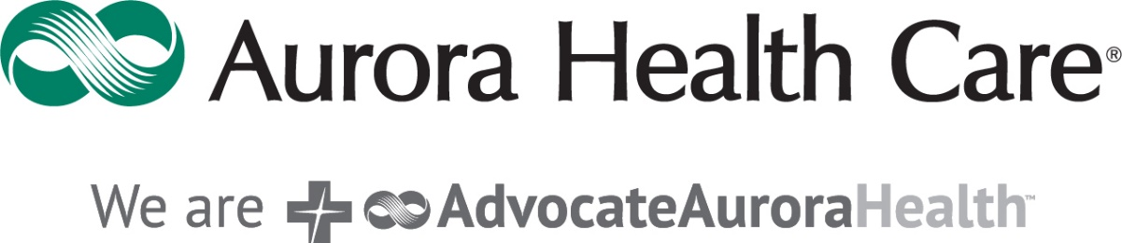

We invite those interested in **Registered Nurse** and **Nursing Assistant** positions to join us for an open house to interview, meet hiring leaders, and possibly leave with a job offer at Aurora BayCare Medical Center!

**Date:** March 7th, 2023  
**Time:** 1:00 pm-5:00 pm  
**Location:** Aurora BayCare Medical Center

(Please use Entrance #1 and proceed to the Arbor Room located near the cafeteria)  
2845 Greenbrier Rd.  
Green Bay, WI 54311

**Register today to reserve your spot**: <https://app.brazenconnect.com/a/AdvocateAurora/e/n33p6>

Like Aurora Health Care, Aurora BayCare is among the 250 health systems and hospitals nationwide participating in the national CMS/Premier Hospital Quality Incentive Demonstration project. Aurora BayCare was named the top-performing hospital in this nationwide demonstration project, and Aurora Health Care was the top-performing health care system in the nation for two years in a row.

Aurora BayCare is committed to bringing health care firsts to the communities it serves, such as: our full on-site fertility program, including in vitro fertilization; deep brain stimulation for movement disorders; endovascular coiling of an intracranial aneurysm; and digital mammography and Mammosite radiation therapy for breast cancer patients. In addition, we feature many Centers of Excellence including: Cancer Care Services; Cartilage Center; Heart, Lung & Vascular Center; Neurovascular & Spine Center; Orthopedic Services; Sports Medicine & Performance Enhancement Center; The Women’s Center; and Minimally Invasive Gynecological surgery