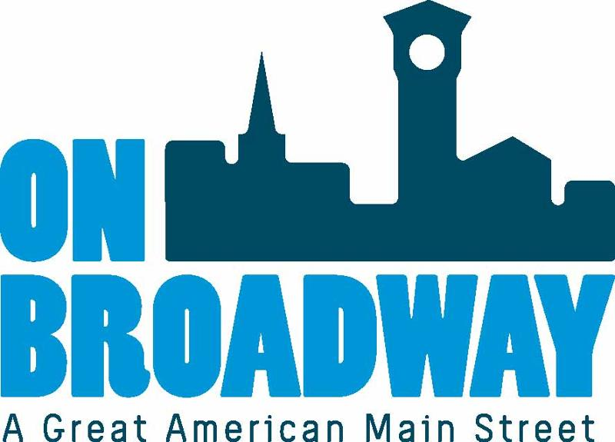
FOR IMMEDIATE RELEASE 07/14/2022
Allie Thut
Director of Special Events
On Broadway, Inc.
(920) 639-6284
allie@onbroadway.org
Brooke Hafs
Marketing Director
On Broadway, Inc.
(920) 680-1226
brooke@onbroadway.org
2022 igNight Market series begins
GREEN BAY, Wis. -- On Broadway is happy to announce igNight Market, presented by Fox Communities Credit Union, is set to return July 16 from 5-10 p.m. in the Neville Public Museum parking lot.
The event feature local artisans and makers, original live music, interactive art demonstrations, street performers, activities, food trucks and more.
Musical Lineup:
- 5 - 6:15 p.m. - Grupo KN ZAvor
- 6:45 - 8:00 p.m. - Phillip-Michael Scales
- 8:30 - 10:00 p.m. - Doctor Nativo
Salon Fifty Four is helping organize a pair of fashion shows at 6:15 and 8:00 p.m. showing off Broadway District business apparel and accessories. The Fab Collab will be building another creation over the course of the igNight Market series to be lit on fire at the fourth event. A log rolling performance will take place on the river around 6:30 and 8:00 p.m.
"We are excited to bring the igNight Market series back to the Broadway District to showcase some underutilized areas," said Allie Thut, Director of Special Events for On Broadway, Inc. "We will transform these spaces into electric atmospheres full of jaw dropping performances and unique experiences."
"The first igNight Market for the season is back! Fox Communities Credit Union is proud to be a part of this one-of-a-kind, free outdoor street festival," said Heather Wessley, the Community Engagement Manager with Fox Communities Credit Union. "Bring your friends and be sure to check out the street performers, live music and delicious food from the food trucks!"
For more information about the event, click here.
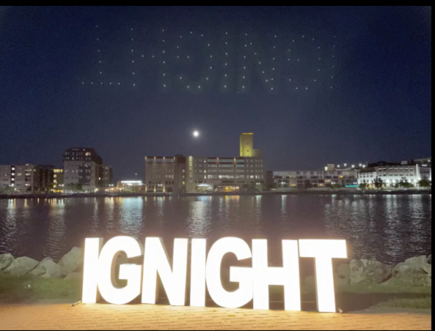
Thank you go our sponsors!
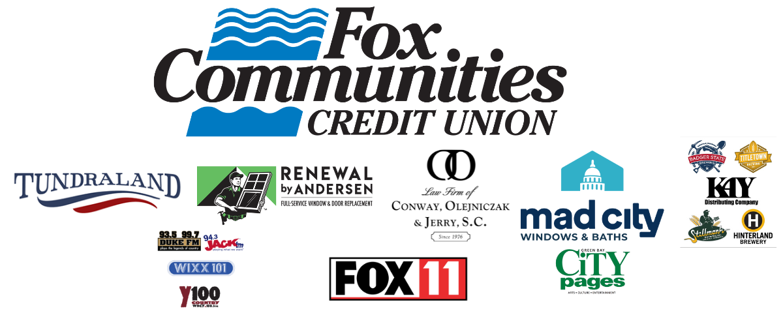
About On Broadway, Inc.
The historic Broadway District is the vibrant, engaging business and residential urban center of Northeast Wisconsin focusing on strategic marketing and staffing, funding and sustainability efforts, event development and coordination of promotions, business and residential recruitment and retention.
On Broadway, Inc. is a non-profit, community-based organization dedicated to strengthening the Green Bay community through economic development, historic preservation and promotion of downtown Green Bay’s Broadway District and the overall downtown community.

