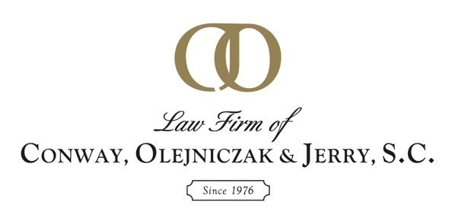
FOR IMMEDIATE RELEASE
Media Contact:
Scott H. Heintz, Administrator
(920) 437-0476
scotth@lcojlaw.com

Law Firm of Conway, Olejniczak & Jerry, S.C.
Hires Attorney Kenneth G. Calewarts

GREEN BAY, Wis. (July 19, 2022) — Attorney Kenneth G. Calewarts recently joined Law Firm of Conway, Olejniczak & Jerry, S.C. His practice is focused on corporate law, commercial litigation and estate planning. He also advises clients on real estate development and leasing, business entity choice and corporate restructuring.

Calewarts brings extensive experience in corporate law, assisting clients in the negotiation, purchase and documentation of mergers and acquisitions ranging from $1 million to $50 million throughout the United States. He also has a substantial estate planning and probate practice throughout Northeast Wisconsin.

“We are excited to welcome Ken to our team,” Attorney and Shareholder Robert Charles shared. “He has been a pillar of the Green Bay area legal community for decades, and we are honored he has chosen to partner with Law Firm of Conway, Olejniczak & Jerry, S.C. to continue his career.”

A Green Bay native, Calewarts is a board member for the Howard-Suamico Historical Society and a frequent lecturer on topics related to his law practice.

Calewarts earned his Juris Doctorate from University of Wisconsin Law School. Calewarts is also a Certified Public Accountant (CPA). Prior to attending law school, he practiced as a CPA with one of the Big Four accounting firms.

About Law Firm of Conway, Olejniczak & Jerry, S.C.:
Since 1976, Law Firm of Conway, Olejniczak & Jerry, S.C. has helped clients solve a variety of legal challenges using a proactive and involved approach. Our reputation for the highest standards of quality has earned us the trust and confidence of businesses and individuals throughout Northeast Wisconsin for over four decades. To learn more, visit lcojlaw.com.

